General SLF-South Processing Workflow
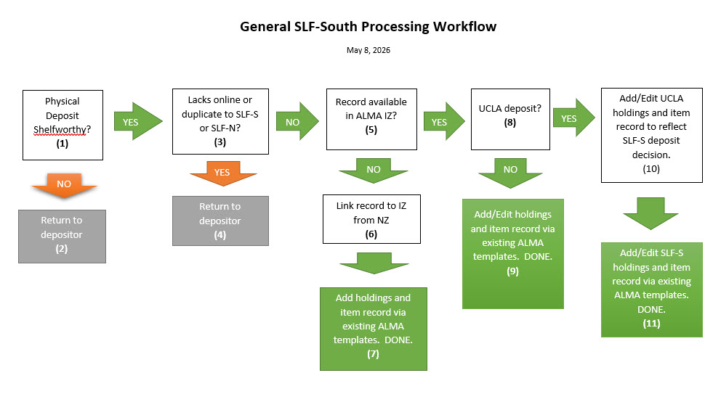
May 8, 2026
- Step 1: Physical Deposit Shelf worthy?
Yes? – Go to step 3
No? – Go to step 2
- Step 2:
Return to depositor
- Step 3:
Lacks online or duplicate to SLF-South or SLF-North?
Yes? – Go to step 4
No? – Go to step 5
- Step 4:
Return to depositor
- Step 5:
Record available in Alma?
Yes? – Go to Step 8
No? – Go to Step 6
- Step 6:
Relink record to IZ from NZ
Go to step 7
- Step 7:
Add holdings and item record via existing Alma templates.
Done
- Step 8:
UCLA deposit?
Yes? – Go to step 10
No? – Go to step 9
- Step 9:
Add/Edit SLF-South holdings and item record via existing Alma templates.
Done
- Step 10:
Add/Edit UCLA holdings and item record to reflect SLF-South deposit decision.
Go to step 11
- Step 11:
Add/Edit SLF-South holdings and item record via existing Alma templates.
Done

